**Converting a Production Major Havoc PCB to Support Major Havoc – The Promised End**

Draft 1.8 - 2/15/2020

Jess M. Askey – [jess@askey.org](mailto:jess@askey.org)

**Summary**

In order to support the updated ROM’s, several modifications need to be performed on the production Major Havoc PCB. The modifications are moderately challenging and you should understand that you might harm your PCB if you make mistakes, do not perform these modifications if you are not willing to accept the risks.

Overall, a few things need to be accomplished in order to run the updated ROM images.

1. Expand the Paged Alpha ROM space
2. Expand the Gamma ROM space
3. Add the speech circuitry if you want speech (technically optional)

The overall process involves adding a single IC to a ‘Spare’ location on the production PCB, adding several jumper wire and cutting one trace.

The modified PCB **\*will\*** still support running production ROM’s if you care to revert back. The cut trace specifically will not cause any functionality to be lost as it is on the speech circuit.

ROM Notes: In the ROM section of this site, refer to the ROM Information.txt file on details about the ROM files and what devices are required for each image. You will need different EPROM’s than the stock Major Havoc ones… notably, there are (3) 27256[32K], (4) 27128[16K] and (1) 2764[8K] EPROM’s required.

Note on Machine Pin Sockets vs Flat Pin Sockets: I actually find the flat sockets to work better even tho they are cheaper. The pins bend out to solder on very nicely. Also, on machine pin sockets, the bottom of the socket pin may inadvertently short to the pin in the socket below, if that happens, it may damage the circuitry. Be aware of those contact considerations.

**Parts List**

The following parts are required for each upgrade Section

Alpha + Gamma CPU (Required):

1. (1) 14-Pin DIP Socket (machine pin or flat)
2. (3) 28-Pin DIP Socket (machine pin or flat, see notes)
3. (1) 74LS174 Hex Flip-Flop

Speech Components (Optional):

1. (1) TMS5220 Speech Generator (11N)
2. (1) 74HC04 CMOS Inverter (9L)
3. (2) 2N3906 Transistors (Q19,Q22)
4. (1) 2N3904 Transistor (Q20)
5. (2) 1K 1/8W resistor (R163,R166)
6. (1) 1.8K 1/8w resistor (R168)
7. (3) 3.3K 1/8W resistor (R161,R164,R167)
8. (2) 10K 1/8w resistor (R162,R165)
9. (1) 4.7K 1/8W resistor (R170)
10. (1) 30-100uf 16v Axial Capacitor (C3) – this may already be installed.
11. (4) .1uf 100v Axial/Radial Ceramic Capacitor (C176,C178,C179,C180)
12. (1) .22uf 50v Mylar Capacitor (C181)
13. (1) LM7905 -5V Regulator (VR4)
14. (1) 28-pin DIP Sockets (note: some PCB’s have the Speech IC socket already stuffed) (11N)
15. (1) 14-pin DIP Socket (9L)

**Alpha + Gamma Upgrade Procedure:**

1. Remove the ROM’s at locations 9S (Gamma) and 1Q + 1N/P (Paged ROM)
2. Solder in a 16-pin DIP socket @ location 5S.
3. Take 3 28-pin DIP sockets and bend pin 27 outwards horizontally so it will stick out when the socket is inserted, you will be soldering wires to these.
4. Plug your modified socket into the main sockets @ 9S, 1Q and 1N/P
5. On the component side, solder a wirewrap wire (30ga Kynar suggested) between pins 27 on 1Q and 1N/P. This line is the chip select for the added Paged ROM space. When you solder to the pin, I suggest that you wrap the wire around the pin so it doesn’t just pop off when you solder to it. You will be soldering another wire to the pin @ 1N/P for reference.
6. On the component side, at the socket @ 9S, solder a wire to pin 27 of the modified socket you installed. Route the wire under capacitors (see pictures below) and attach the other end to the 74LS139 IC @ 8R pin 13 (signal A14). Gamma mods are now complete.
7. Now, moving to the solder side (underside of the PCB) we will start adding the new wires for the page select.
8. Solder a wire from the new socket @ 5S, pin 1 (Reset) to the Alpha CPU 6502 @ 2S pin 40.
9. Solder a wire from the new socket @ 5S, pin 9 (Clock) to the Address Decoder 74LS138 @ 5N pin 10.
10. Solder a wire from the new socket @ 5S, pin 13 (D2) to the Data Buffer 27LS244 @ 5S pin 16.
11. Solder a LONG wire from the new socket @ 5S, pin 12. You are going to then take this wire up to a through hole in the PCB (see picture below) and then route this wire under capacitor leads to help guide the wire towards the ROM socket @ 1N/P… solder this wire neatly to pin 27 @ 1N/P.
12. We are now going to start the modifications for the speech circuit.
13. Stuff all the parts from the parts list using the below table… be careful to match polarity on the electrolytic capacitor.

**Speech Upgrade Procedure:**

1. If you do not have a socket installed @ location 10M, install one now.
2. Install the 14-pin DIP Socket @ location 9L.
3. Stuff the components listed above at the locations specified. Use the photos below and the PCB silkscreen photo below.

Full size Images can be found here - <https://github.com/jessaskey/mhavocpe/tree/master/Conversion/Photos>

**Alpha CPU Conversion Photos:**

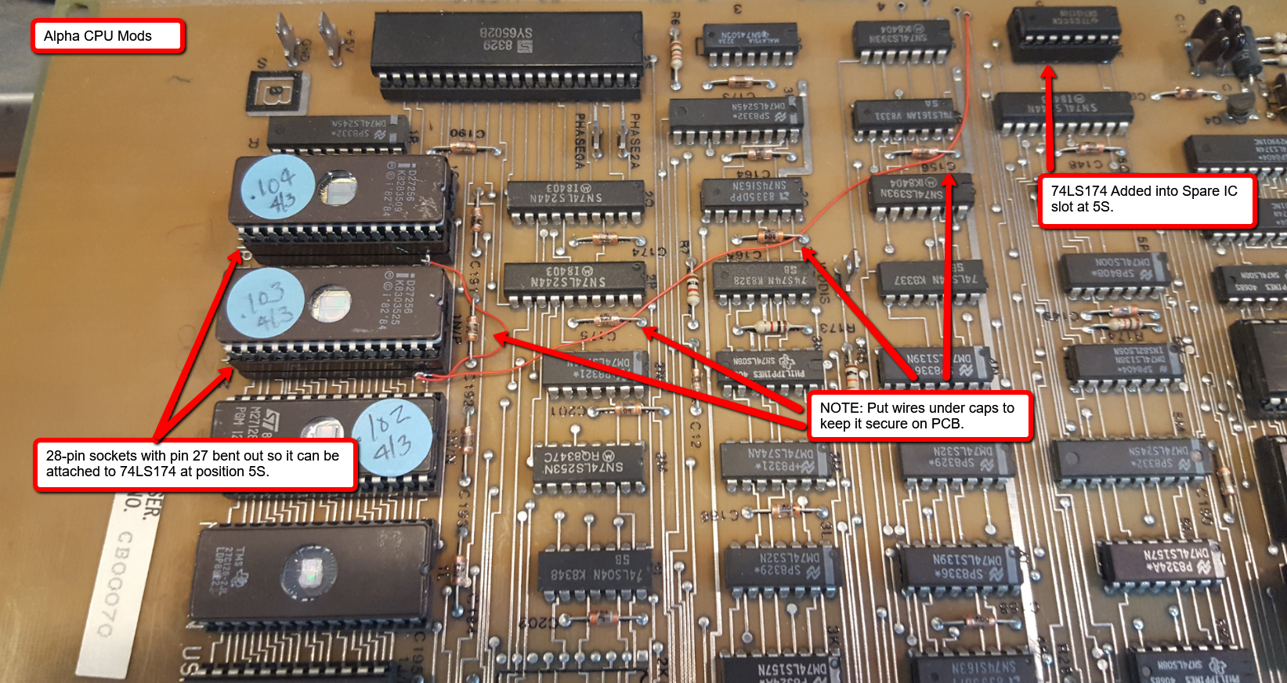

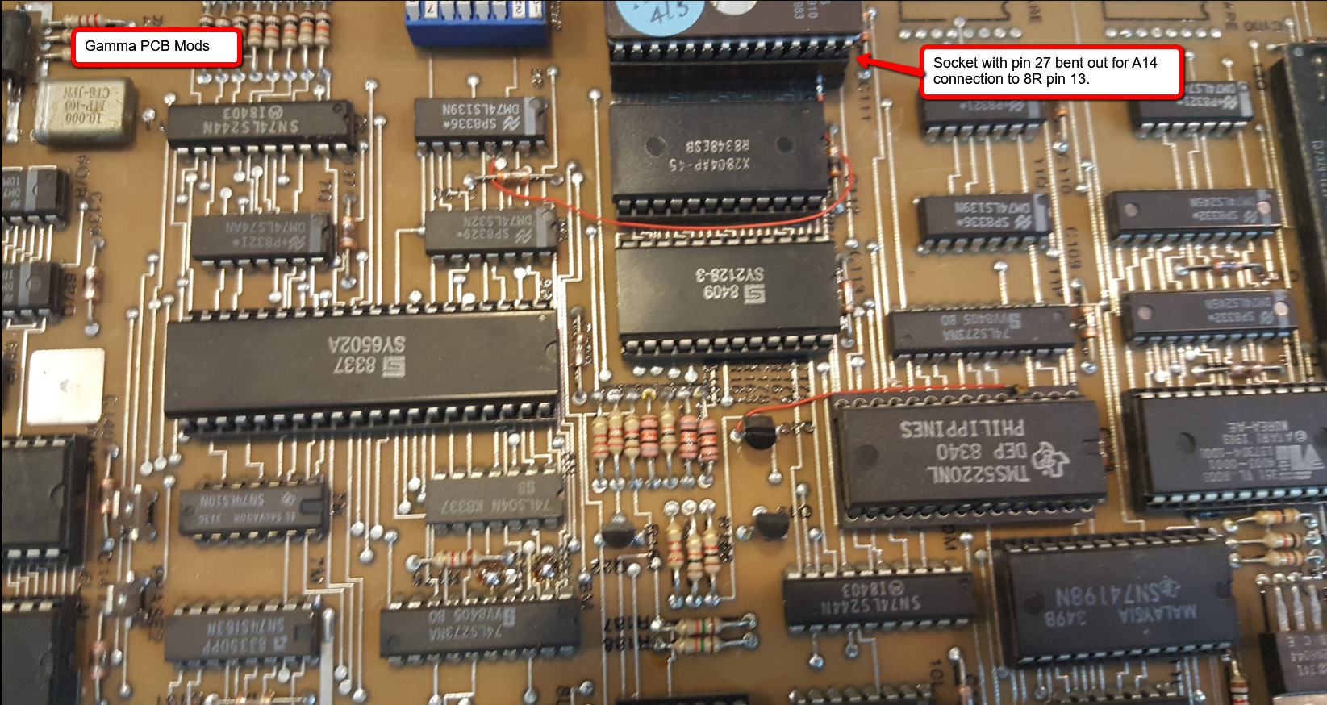

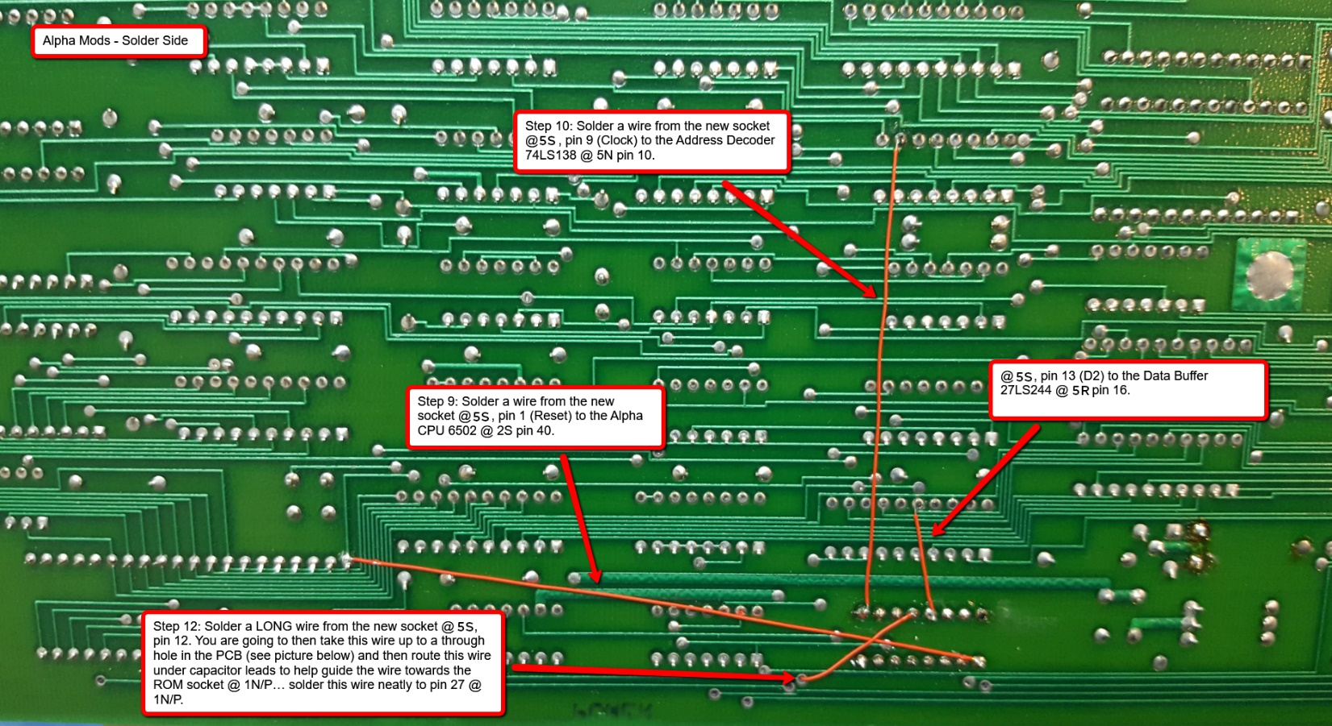

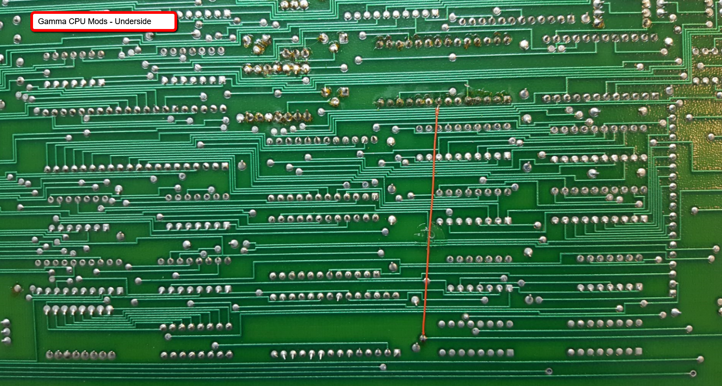

**Speech Circuit Photos:**

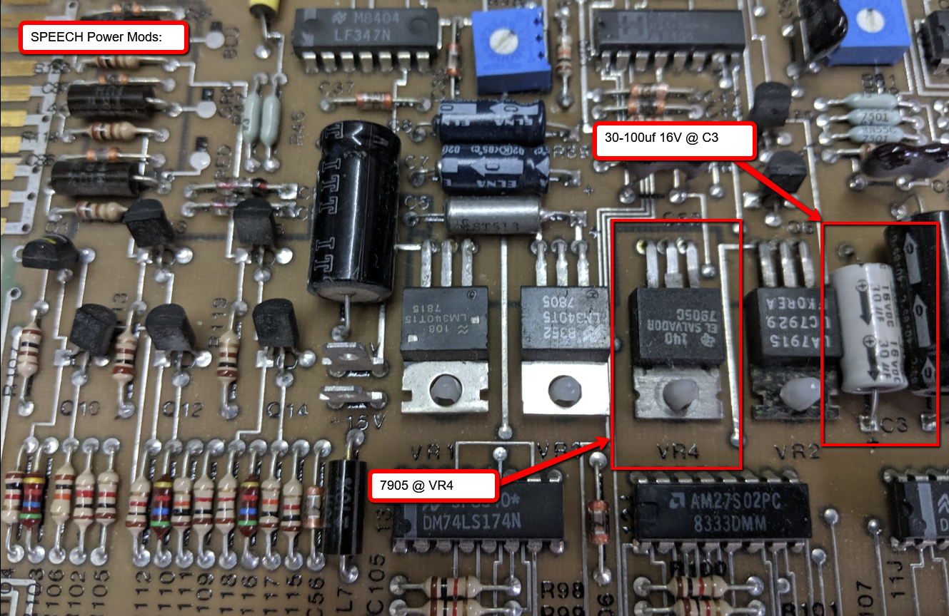

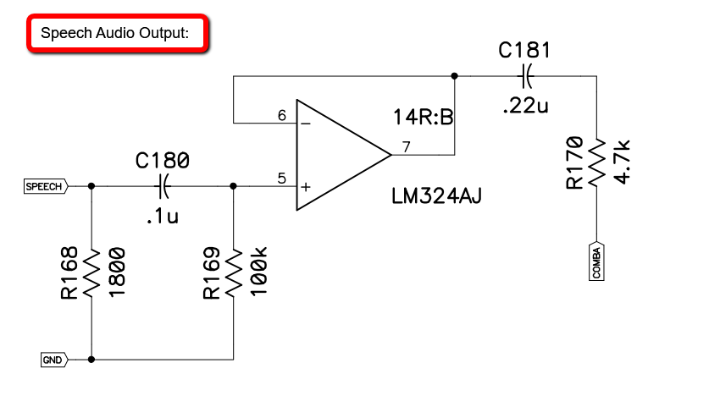

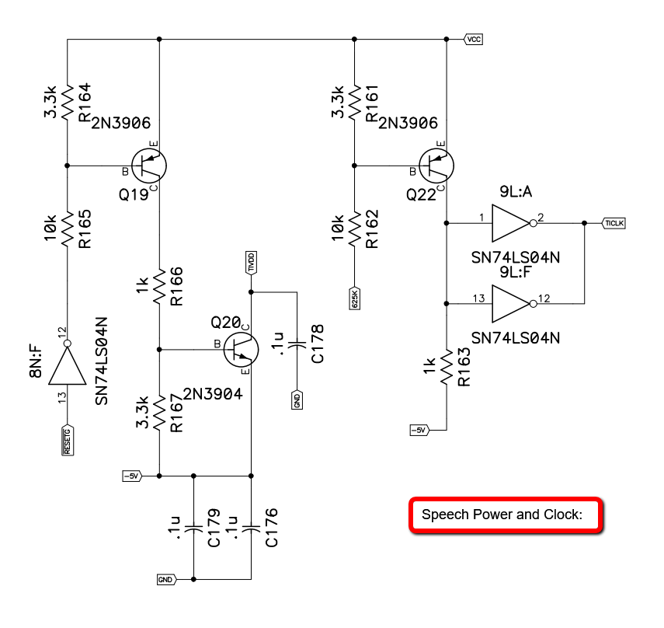

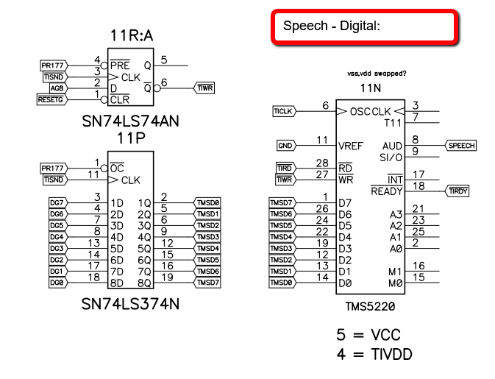

**NOTE**: The IC @ 11P may be a 74LS273… it should already be installed. If it is not, install a 20-pin socket and a 74LS273 in this spot. If you have a Repro PCB from Luke Dyson, you can install a 74LS374 in this spot.

**PCB Silkscreen Layer from Luke Dyson:**

This image is also on the github site in the Conversion/Photos directory.. it is higher resolution than this version. This will help you determine the component positions because the silkscreens on the actual PCB can be hard to read.

NOTE: There seems to be a few differences between dedicated PCB’s and potentially conversion PCB’s in this area. I believe the components are just in slightly different places but I don’t have any specifics. If you run across differences, I would be interested in hearing what they are from this layout.

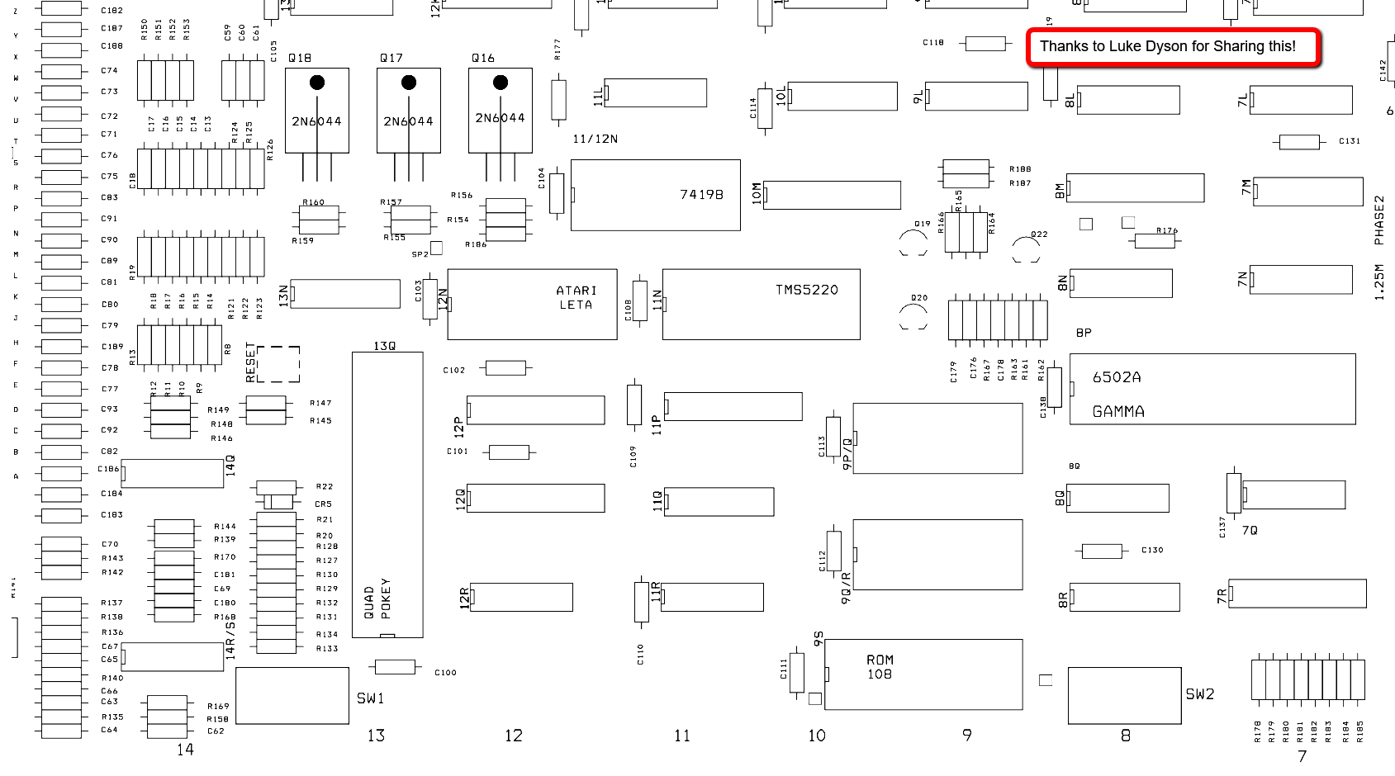

Document History:

* Draft 1.8 – 2/15/2020 – Added note about the IC and/or circuit differences around the Latch at 11P.
* Draft 1.7 – 2/12/2020 – Fixed annotation typos on PCB Solder Side, started adding pictures and better documentation for Speech Section.
* Draft 1.6 – 5/12/2018 – Added Speech Schematics from Mark Spaeth.
* Draft 1.5 - 5/2/2018 – Added notes on EPROM sizes required.
* Draft 1.4 - 5/1/2018 – Fixed mis-labeled location 5R with correction location 5S.
* Draft 1.3 - 4/19/2018 – Added text on photos
* Draft 1.2 – 4/15/2018 – Added photos
* Draft 1.1 - ?
* Draft 1.0 - ? – Initial draft